# **Deep RNNs | Stacked RNNs | Stacked LSTMs | Stacked GRUs**

[deep-rnns.ipynb](https://colab.research.google.com/drive/10vBoQpr-dcQJDZPBQxBZQLo0C29Uj21J?usp=sharing)







Doing this same thing in rnn called deep RNN

### **Notes on Deep RNNs (Stacked RNNs)**

**What are Deep RNNs?**

* Deep RNNs, also known as Stacked RNNs, are created by stacking multiple layers of RNNs on top of each other.
* The basic concept is to stack multiple layers of RNNs to solve more complex problems.
* This is a similar concept to adding more hidden layers in a basic Artificial Neural Network (ANN) to improve its representation power and handle complex data patterns.

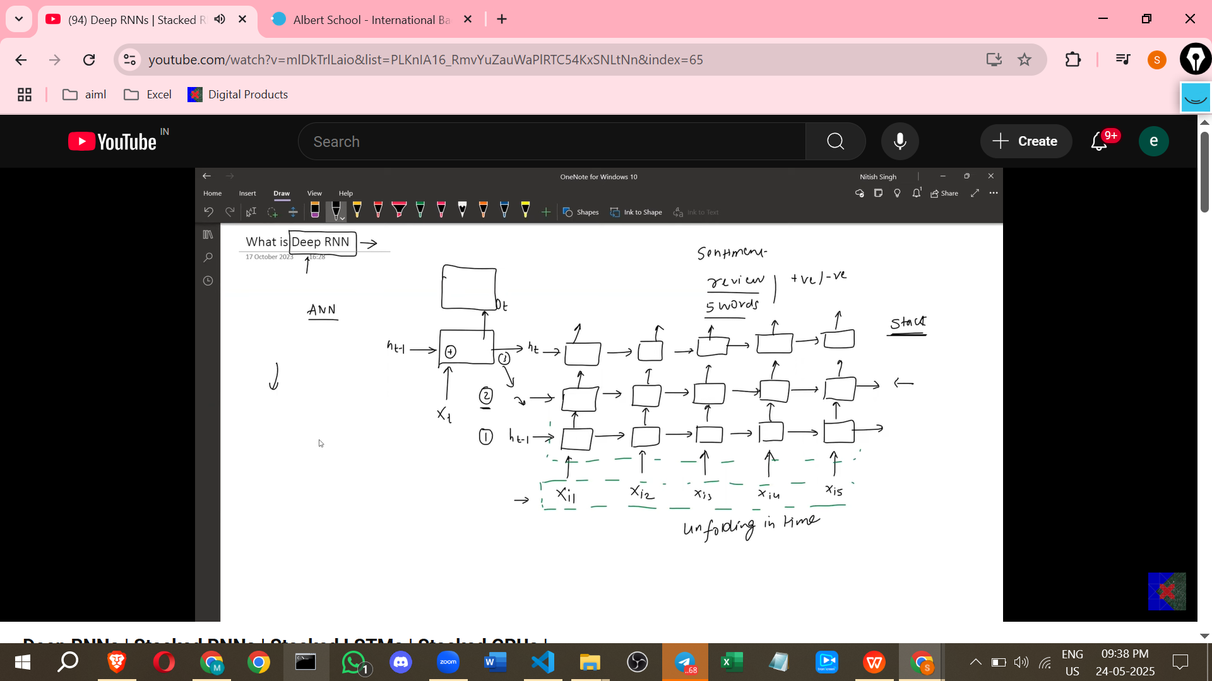

**Motivation for Deepening Neural Networks**

* Adding more neurons to a single hidden layer can improve a simple ANN's performance on complex data like the spiral dataset. This is because it increases the network's representation power, allowing it to find data patterns more effectively.
* If increasing neurons in a single layer isn't sufficient, adding more hidden layers can further improve results.
* Adding more hidden layers and nodes increases the neural network's complexity and improves its ability to capture complex patterns, leading to better results.
* The same concept of adding layers to create a more complex model can be applied to RNNs, resulting in Deep RNNs.

**Architecture of a Simple RNN (Review)**

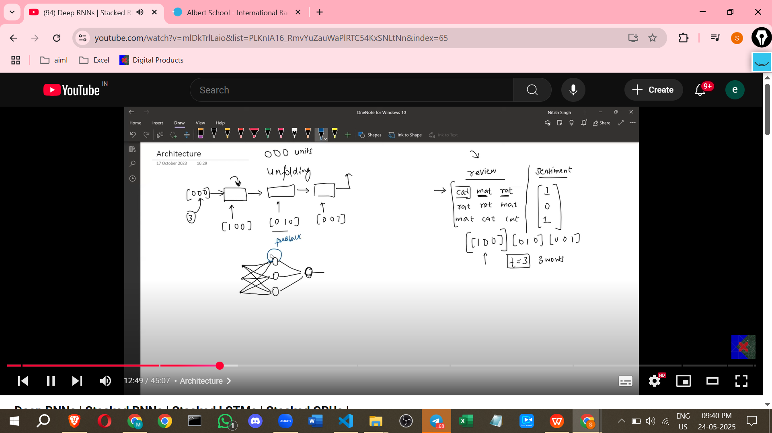

* A simple RNN processes input word by word for tasks like sentiment analysis.
* At each time step (t), the RNN cell receives the current word's input (e.g., xt) and the output from the previous time step (ht-1).
* These inputs undergo an operation, typically involving a tanh activation function, to produce the current time step's output (ht).
* A sigmoid activation function might be used on the final output to produce a classification (e.g., positive/negative sentiment).
* When unrolled in time, a simple RNN shows one block (RNN cell) for each time step, with the output of one time step feeding into the next as the previous hidden state.
* A key characteristic is the recurrent connection or feedback loop, which is essentially a connection from the output of the cell back to its input for the next time step.

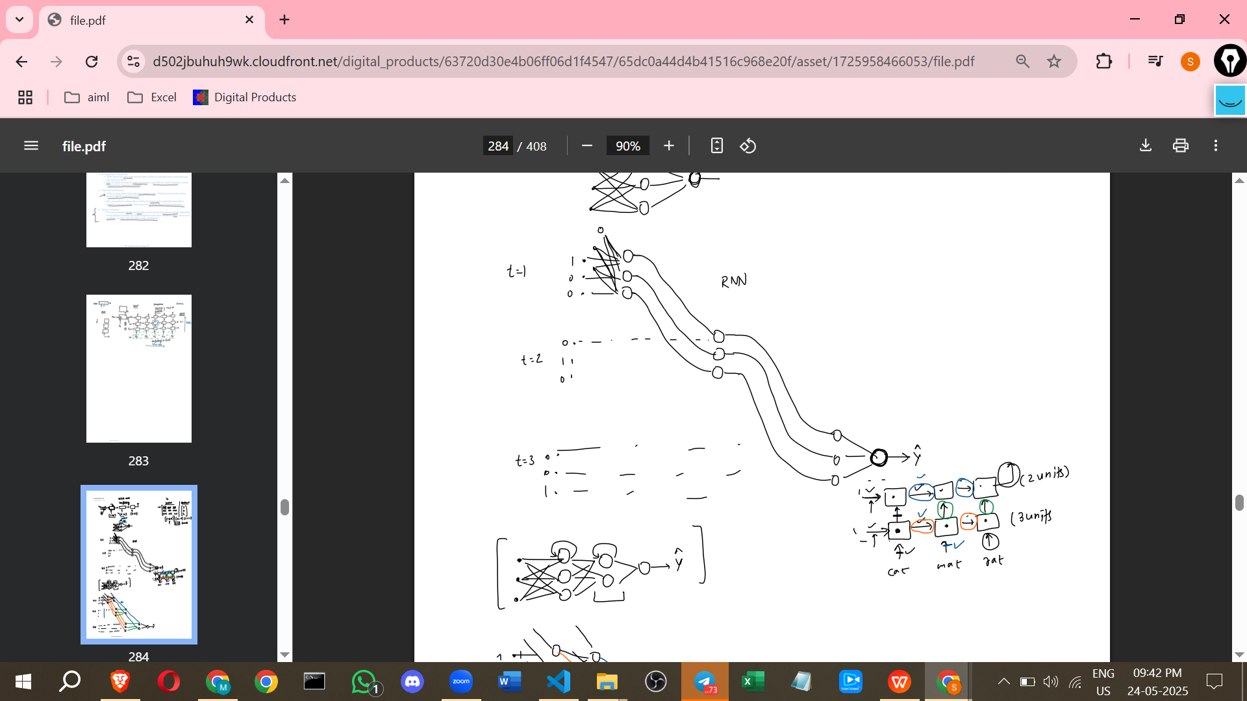

**Architecture of a Deep RNN (Stacked RNNs)**

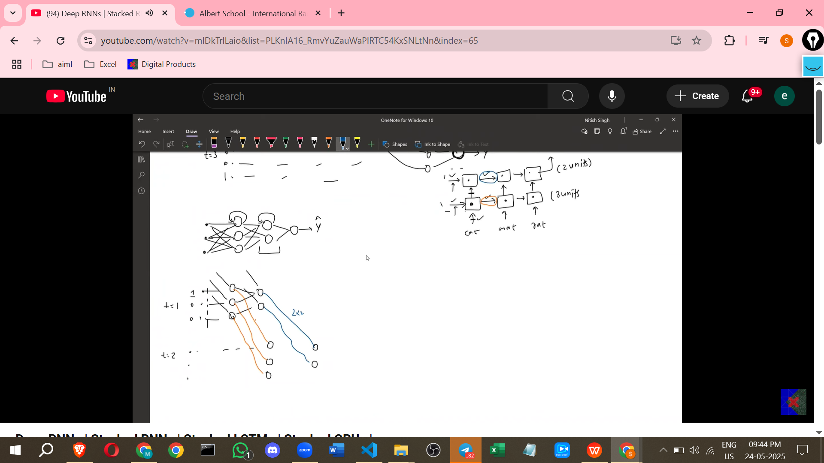

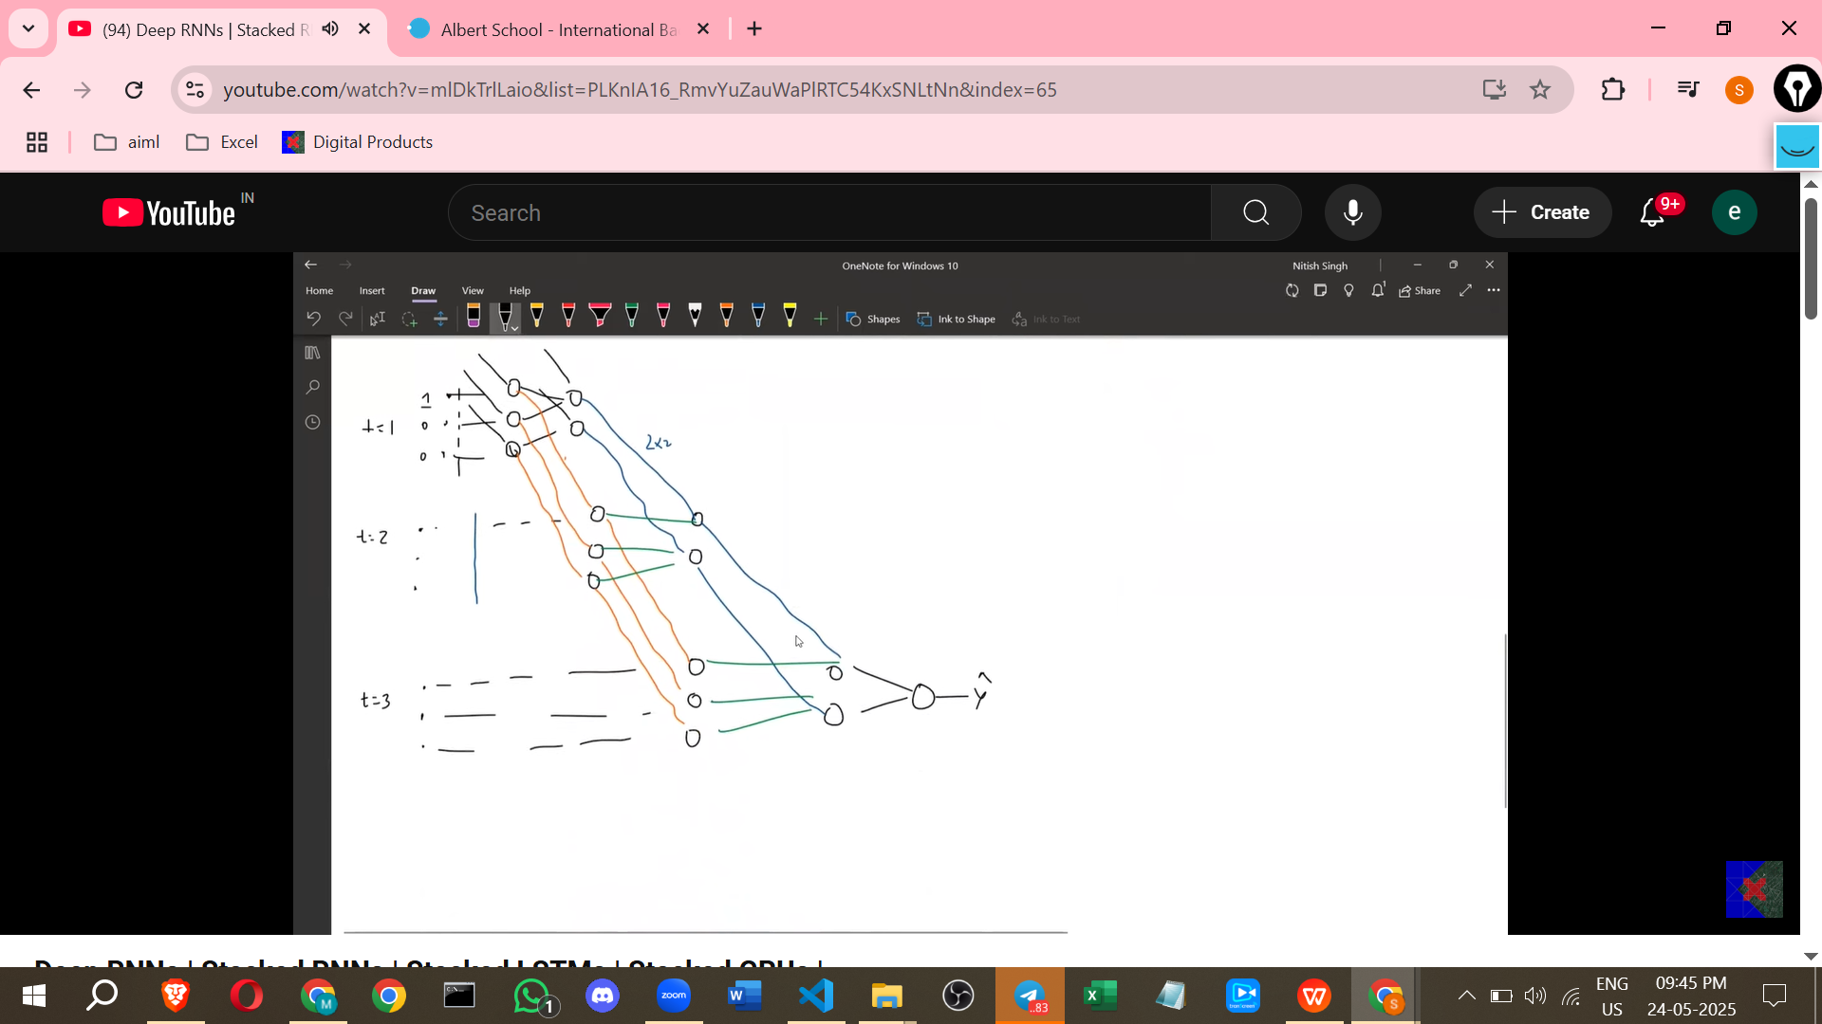

* If a simple RNN doesn't perform well (e.g., low accuracy), additional hidden layers can be added.
* In a Deep RNN, multiple RNN cells (or layers) are stacked vertically.
* For example, with two hidden layers, the first hidden layer receives input directly from the input layer.
* The second hidden layer receives input from the output of the first hidden layer at the *same* time step.
* Each hidden layer also receives input from its own output from the *previous* time step, maintaining the recurrent nature.
* There is no limit to how many hidden layers can be stacked vertically.
* This vertical stacking, combined with unrolling in time, shows how information flows across both time steps and layers.
* The output of one layer at a given time step becomes the input for the layer above it at the same time step.

**Notation for Deep RNN Cells**

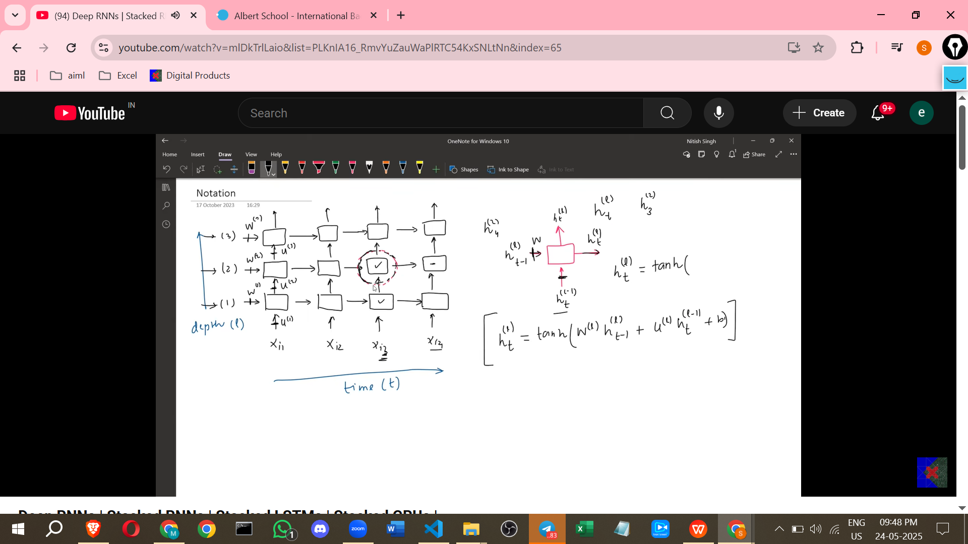

* Deep RNNs can be visualised as a grid with two axes: the Time axis (T) and the Depth axis (L, for layer).
* An individual RNN cell within this grid is identified by its time step (t) and layer number (l).
* A hidden unit at time step 't' and layer 'l' is denoted as h^l_t.
* The input from the layer *below* the cell (at the same time step) is denoted as h^(l-1)_t.
* The input from the *previous time step* (in the same layer) is denoted as h^l_(t-1).
* The output of the cell is h^l_t, which feeds into the layer above (h^(l+1)_t) and the same layer at the next time step (h^l_(t+1)).
* The calculation for a hidden unit h^l_t involves the tanh activation function and weighted sums of its two inputs (from below and from the previous time step), plus a bias.
* Each layer 'l' has its own set of weights: W^l for the connection from the previous time step within the same layer (h^l_(t-1)), and U^l for the connection from the layer below at the current time step (h^(l-1)_t).
* The general equation for a Deep RNN cell's output is: h^l_t = tanh(W^l * h^l_(t-1) + U^l * h^(l-1)_t + b^l).

**Why and When to Use Deep RNNs**

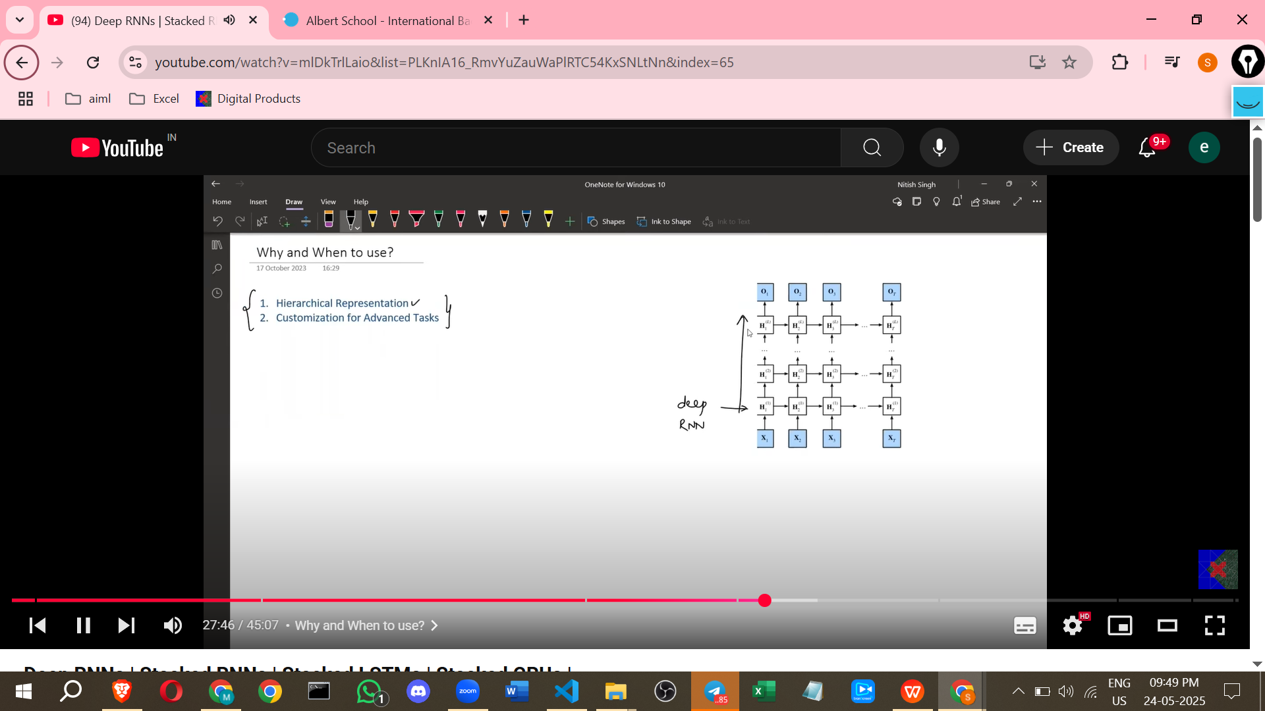

* **Complex Data:** Deep RNNs are motivated by the complexity of the data being processed.
* **Hierarchical Representation:** Stacking layers allows the network to learn hierarchical representations of the data.
  + Lower layers can capture primitive features (e.g., words like "love", "hate").
  + Middle layers can understand features at a sentence or phrase level (e.g., "audio is bad").
  + Higher layers can integrate information from lower layers to understand the overall sentiment or meaning (e.g., "audio is bad but display is great, overall I'm happy").
  + This hierarchical understanding aligns with the structure of sequential data like text (words forming sentences, sentences forming paragraphs).
* **Customization for Advanced Tasks:** Deep RNNs can be used as components in advanced architectures for complex tasks.
  + Example: Used in encoder-decoder modules with attention mechanisms for machine translation (like Google Translate).

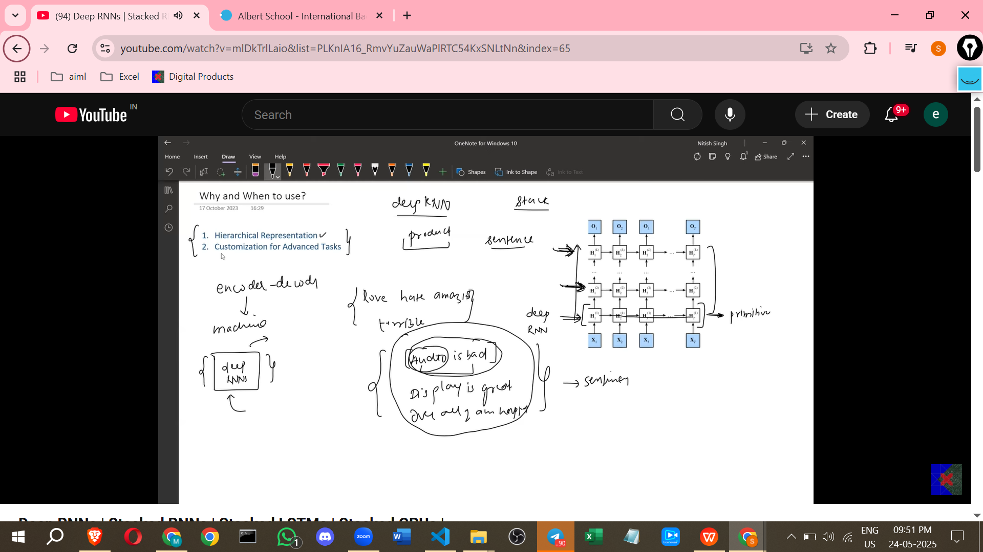

* **Scenarios for Use:**
  + **Complex Problem Statements:** Problems like speech recognition or machine translation where deep architectures are beneficial.
  + **Large Datasets:** Deep RNNs generally require substantial data to avoid overfitting.
  + **Sufficient Computational Resources:** Training deep networks requires significant processing power and time.
  + **Unsatisfactory Results with Simpler Models:** If a single-layer RNN does not yield good performance, a Deep RNN can be tried as an improvement.

**Implementation in Keras (IMDB Sentiment Analysis Example)**

[**deep-rnns.ipynb**](https://colab.research.google.com/drive/10vBoQpr-dcQJDZPBQxBZQLo0C29Uj21J?usp=sharing)

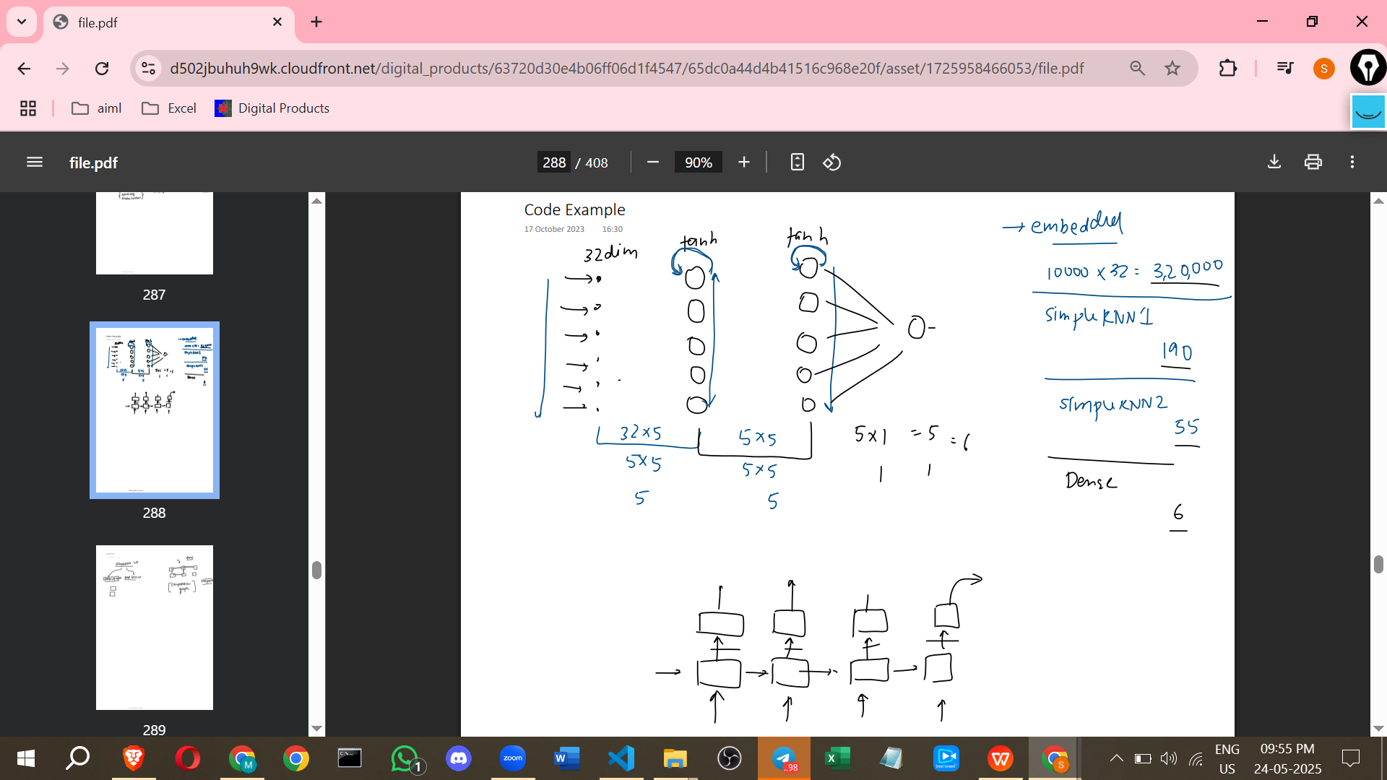**\**

* Using Keras, one can stack multiple SimpleRNN layers to create a Deep RNN.
* An Embedding layer is typically used first to convert input words (represented as integers) into dense vectors. The layer size depends on the vocabulary size and desired embedding dimension (e.g., 10000 words, 32-dimension vectors).
* Subsequent layers are SimpleRNN layers. Each layer needs to specify the number of units (e.g., 5 units).
* A final Dense layer with a sigmoid activation is used for binary classification (e.g., sentiment analysis).
* **Important:** For all intermediate hidden layers in a Deep RNN (i.e., all but the last hidden layer), the return_sequences parameter must be set to True. This ensures that the output sequence of the layer at each time step is passed as input to the layer above it.
* The *last* hidden layer (before the final output layer) typically has return_sequences=False because the final output might only be needed from the last time step (e.g., final sentiment after processing the whole review). If output was needed at every time step, this would also be True.
* The total number of parameters in the model increases with each added layer, including weights for the recurrent connections within the layer and connections from the layer below, plus biases.

**Extending the Concept: Deep LSTMs and Deep GRUs**

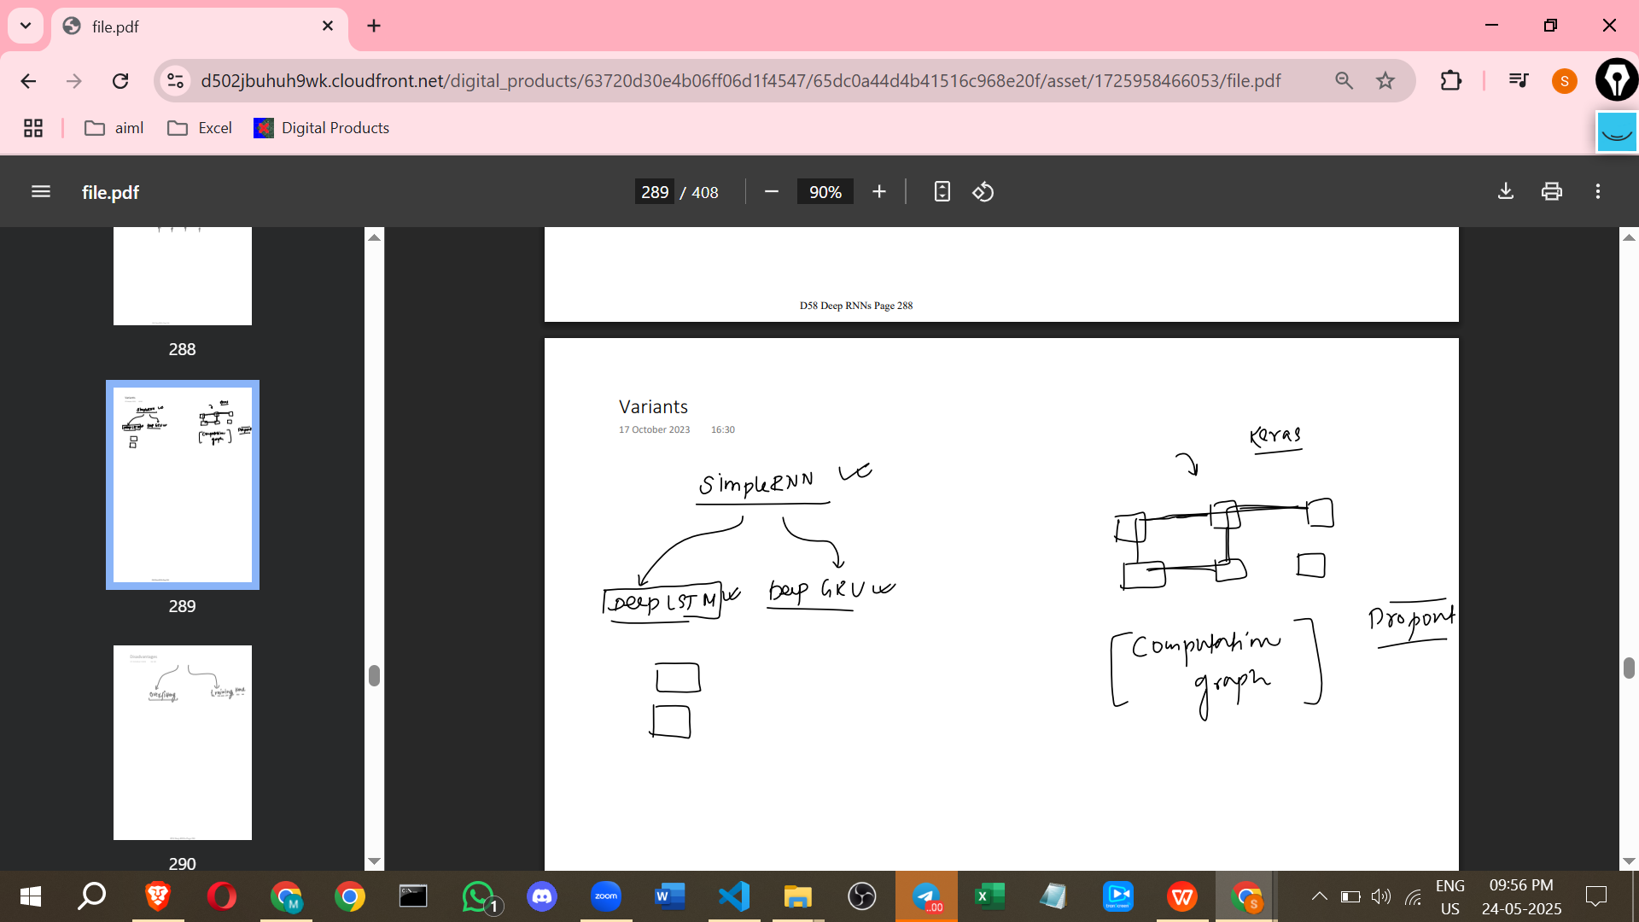

* The concept of stacking layers is not limited to simple RNNs.
* It can be applied to more advanced RNN architectures like LSTMs and GRUs.
* One can create **Deep LSTMs** by stacking multiple LSTM layers.
* One can create **Deep GRUs** by stacking multiple GRU layers.
* In practice, Deep LSTMs and Deep GRUs are more commonly used than Deep SimpleRNNs because LSTMs and GRUs help mitigate issues like vanishing gradients, which can still occur in Deep SimpleRNNs.
* Implementation in Keras is straightforward; simply replace SimpleRNN layers with LSTM or GRU layers.

**Disadvantages of Deep RNNs**

* **Increased Complexity:** The network architecture is more complex, requiring careful design and hyperparameter tuning (e.g., using dropout, regularisation, setting learning rates, weight initialization) to prevent overfitting.
* **Increased Training Time:** Training takes longer because there are more parameters to update through backpropagation, requiring more calculations of derivatives. This is especially noticeable with large datasets.

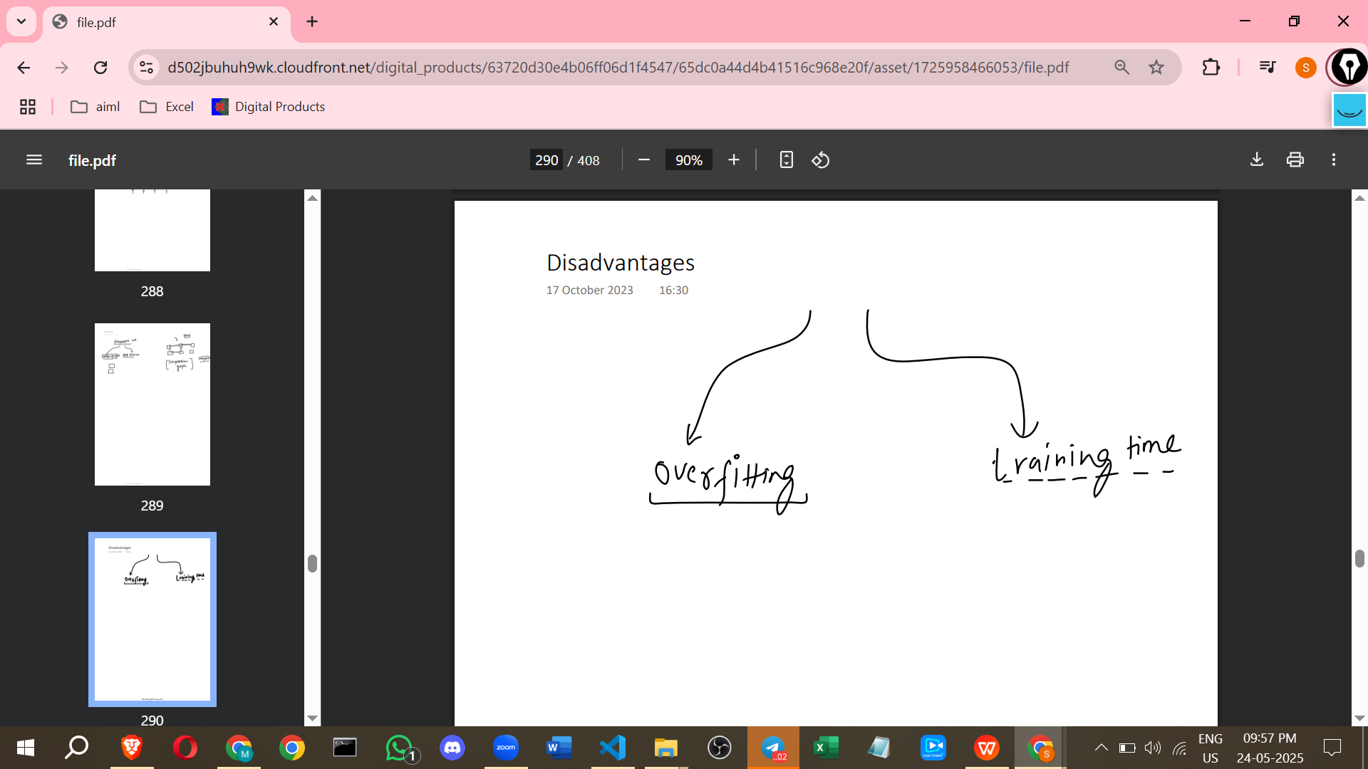

### **Additional Points to Aid Learning**

* **Deep vs. Simple:** Think of "deep" in neural networks as adding more vertical processing layers, allowing the network to build up more abstract or complex representations of the input data. Simple (or shallow) networks have fewer such processing layers.
* **Hierarchical Processing Analogy:** The hierarchical representation learned by Deep RNNs is similar to how we might process a book: first understanding individual words, then combining them to grasp sentence meaning, then paragraphs, and finally the overall theme or sentiment of the text.
* **Visualising Information Flow:** The unrolled diagram of a Deep RNN clearly shows information flowing both *horizontally* (across time steps within a layer, via recurrent connections) and *vertically* (upwards through the layers at each time step).
* **Parameter Count:** As shown in the Keras example, adding layers significantly increases the total number of trainable parameters in the model. This is why more data and computational resources are needed for Deep RNNs.
* **return_sequences=True:** This is a crucial parameter in Keras when building stacked RNNs (be it SimpleRNN, LSTM, or GRU). If it's False for an intermediate layer, that layer will only output the state from the *last* time step, preventing the layer above from receiving inputs for all time steps.
* **Why Deep LSTMs/GRUs are Preferred:** Simple RNNs struggle with long sequences due to vanishing/exploding gradients. Stacking them (Deep SimpleRNNs) doesn't fundamentally solve this issue. LSTMs and GRUs were designed to handle long-range dependencies, making their deep versions (Deep LSTMs/GRUs) more robust for complex sequential tasks.
* **Experimentation is Key:** The source recommends experimenting with single-layer vs. deep versions of SimpleRNN, LSTM, and GRU on a dataset to see the practical differences in performance and training.

==============================================

# **Class 2 Bidirectional RNN | BiLSTM | Bidirectional LSTM | Bidirectional GRU**

Here are notes on Bidirectional RNNs based on the source you provided:

* **Introduction and Context**:  
  + Bidirectional RNNs are discussed after covering Vanilla RNNs, LSTMs, GRUs, and Deep RNNs.
  + Vanilla RNNs, LSTMs, and GRUs process information sequentially.
  + Deep RNNs involve stacking multiple RNN cells on top of each other to capture deeper patterns.
* **Motivation for Bidirectional RNNs**:  
  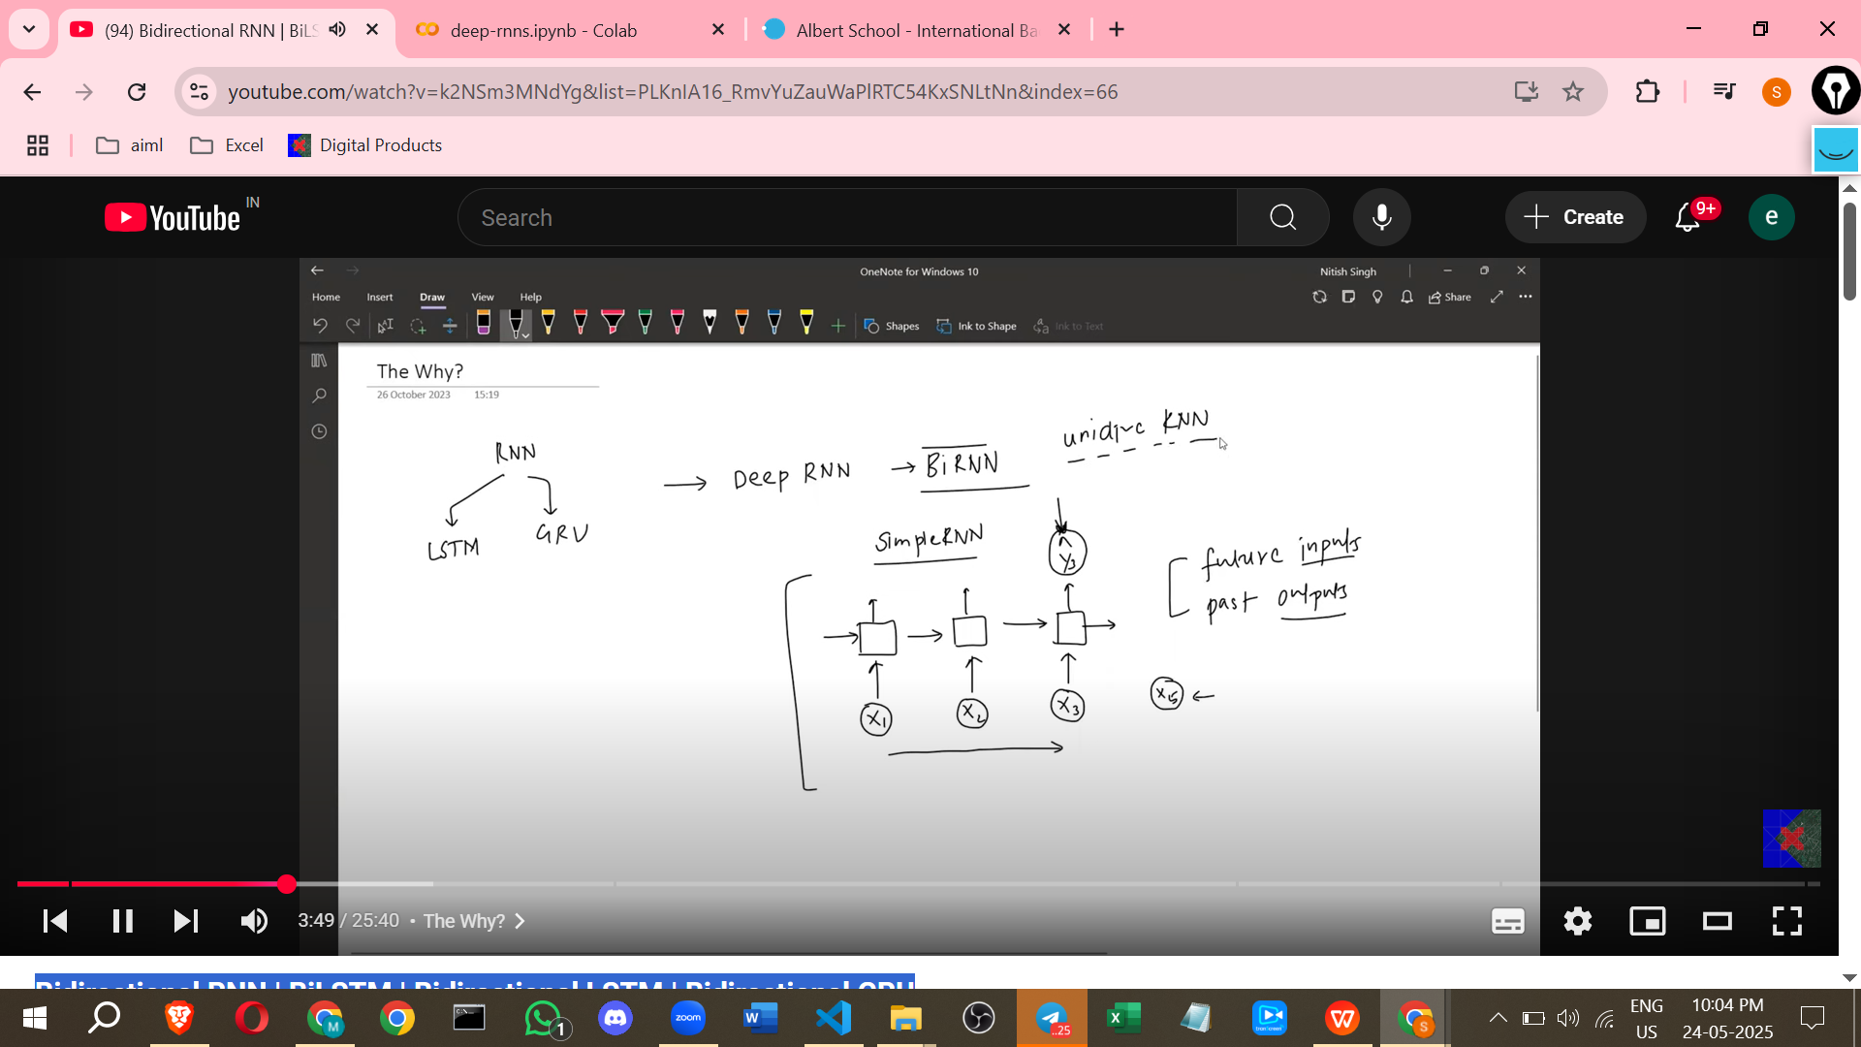
  + Simple or unidirectional RNNs process inputs step by step, from past to present.
  + The final output of a unidirectional RNN typically depends on past inputs.
  + This design fails in scenarios where future inputs affect past outputs.
  + **Challenge**: How to handle situations where understanding something at an earlier time step requires knowing what comes later in the sequence?
* **Example Scenario (Named Entity Recognition - NER)**:



* + NER is an NLP task where you identify and classify entities (like persons, locations, organisations) within a sentence.
  + Consider the sentences: "I love Amazon it's a great website" and "I love Amazon it's a beautiful river".
  + If you process word by word from left to right using a simple RNN, when you reach the word "Amazon", you don't know if it refers to the company (organization) or the river (location).
  + The information needed to resolve this ambiguity ("website" or "river") comes *after* the word "Amazon".
  + A simple unidirectional RNN (including standard LSTM or GRU) only has information up to the current word, not the future words, at that time step.
  + This is a scenario where future input (words like "website" or "river") affects the output (the entity type of "Amazon") at an earlier time step.
  + Bidirectional RNNs are needed here because they can process information from both directions.

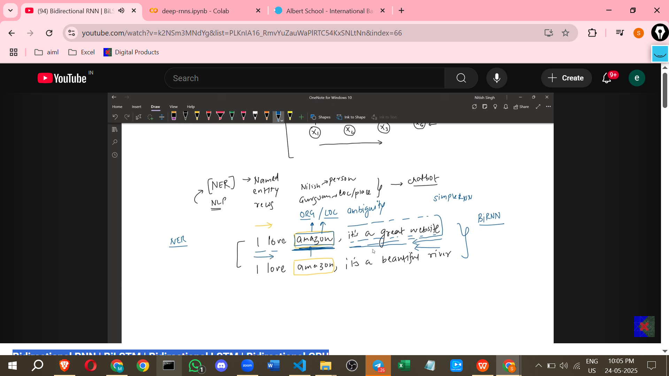

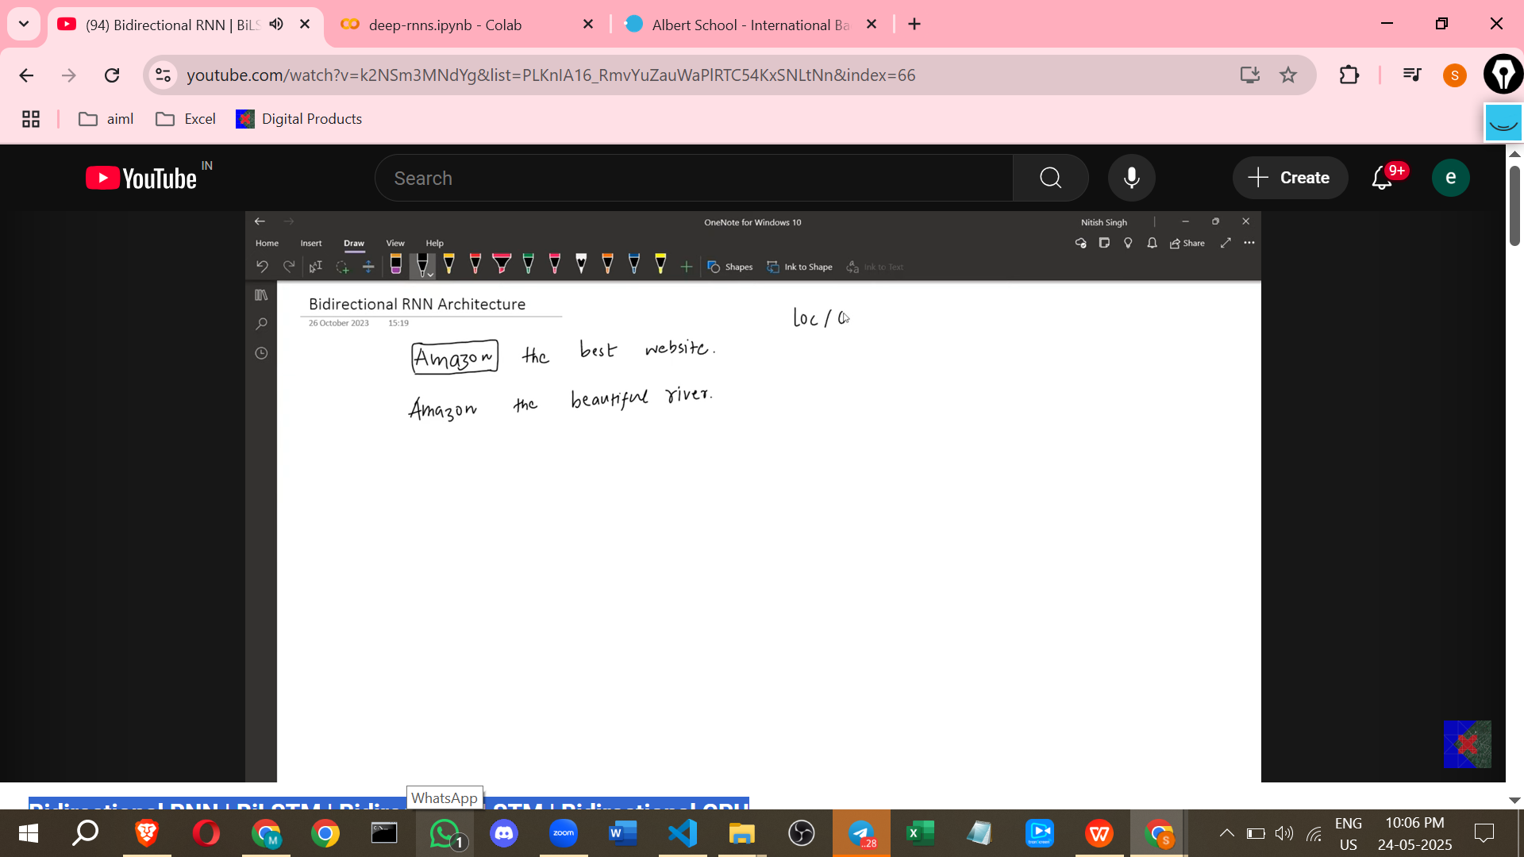

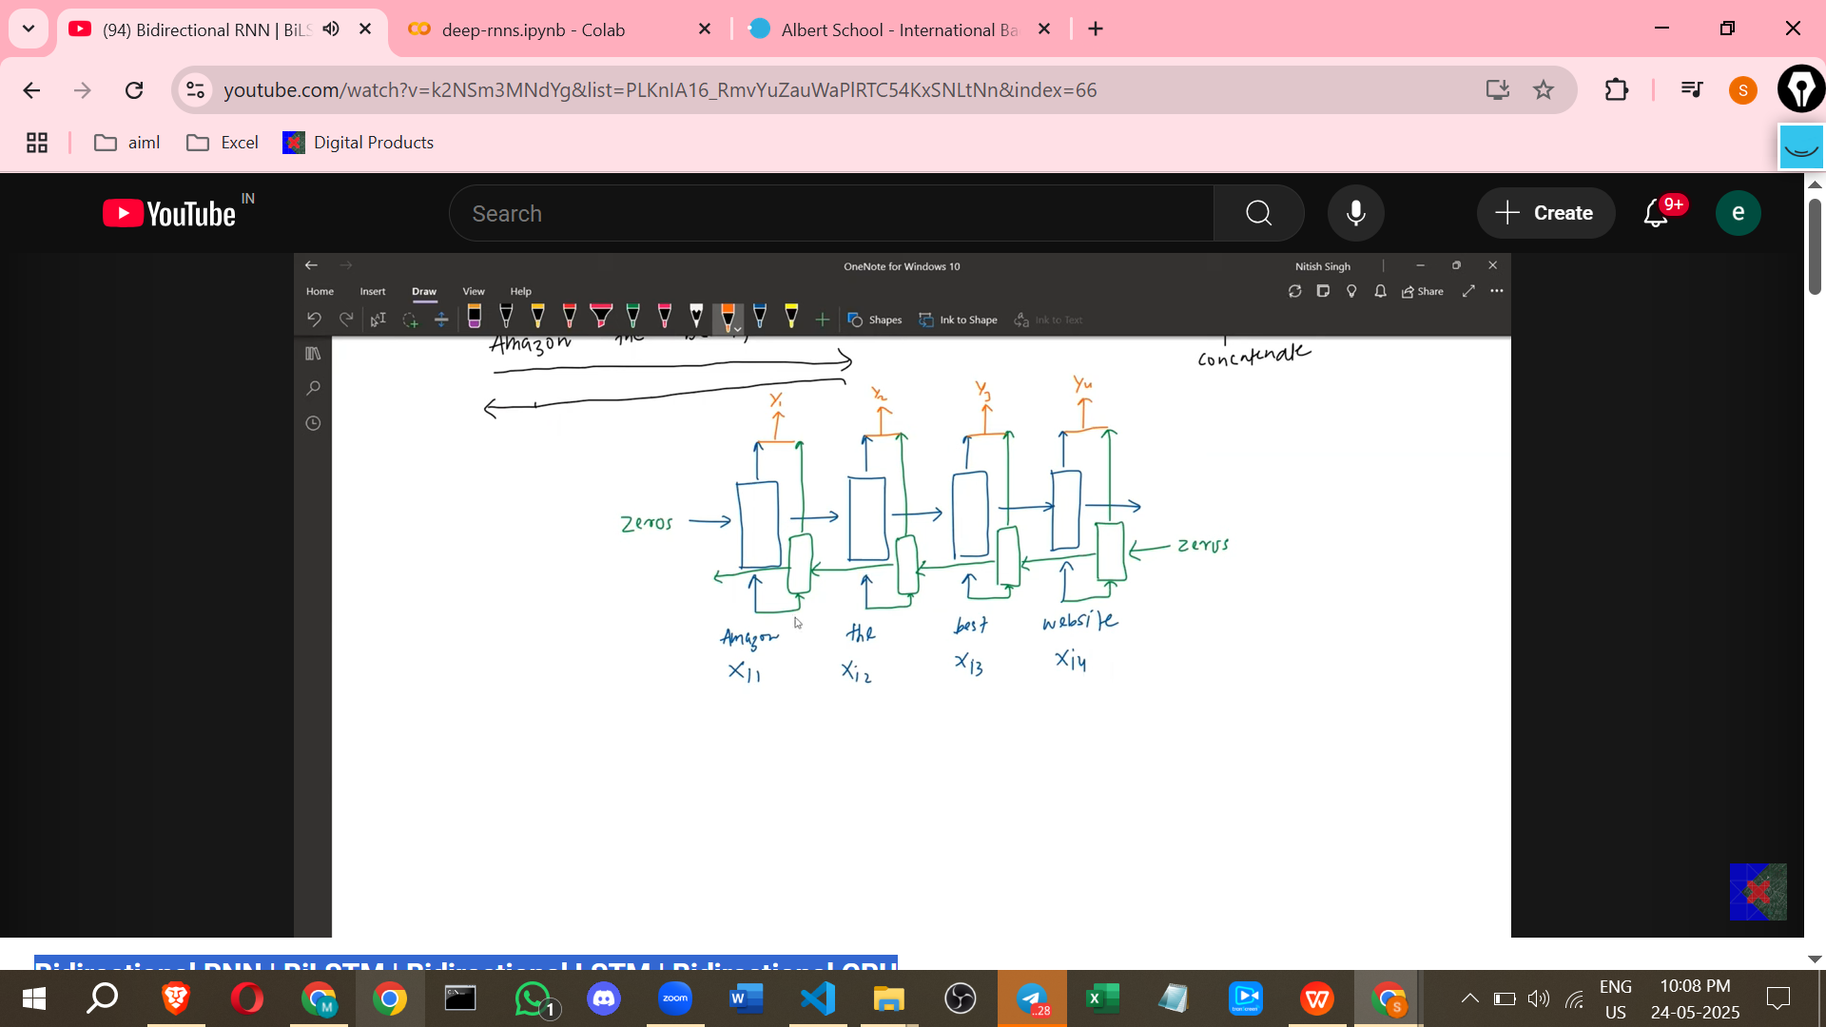

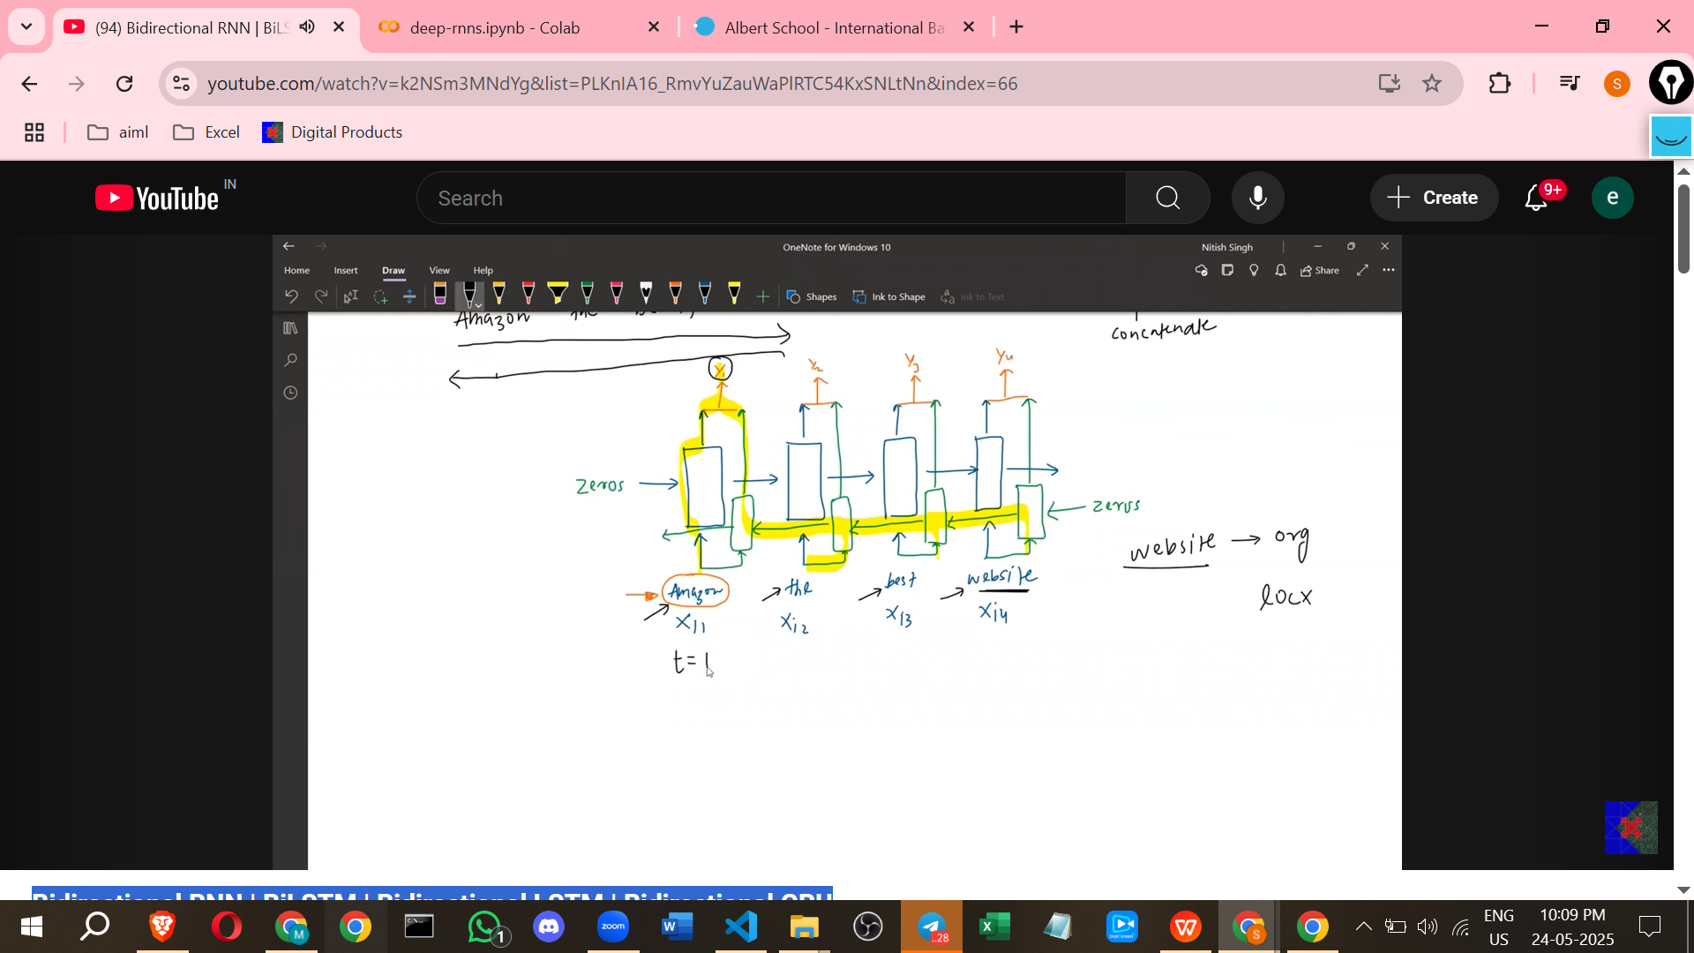

* **How Bidirectional RNNs Work**:  
  + They solve the problem of needing future context by using **two separate RNNs**.
  + **Forward RNN**: Processes the input sequence from **left to right** (the usual direction).
  + **Backward RNN**: Processes the input sequence from **right to left** (the reverse direction).
  + At each time step, the outputs (or hidden states) from the forward RNN and the backward RNN are **concatenated** (joined together).
  + This concatenated output for a given time step contains information from both the words that came *before* it and the words that come *after* it in the sequence.
  + For the "Amazon" example, at the time step corresponding to "Amazon", the output combines the forward context (e.g., "I love") and the backward context (e.g., "it's a great website"). This allows the model to correctly classify "Amazon" as an organisation because it has access to the word "website".
* **Equations (Core Idea)**:  
  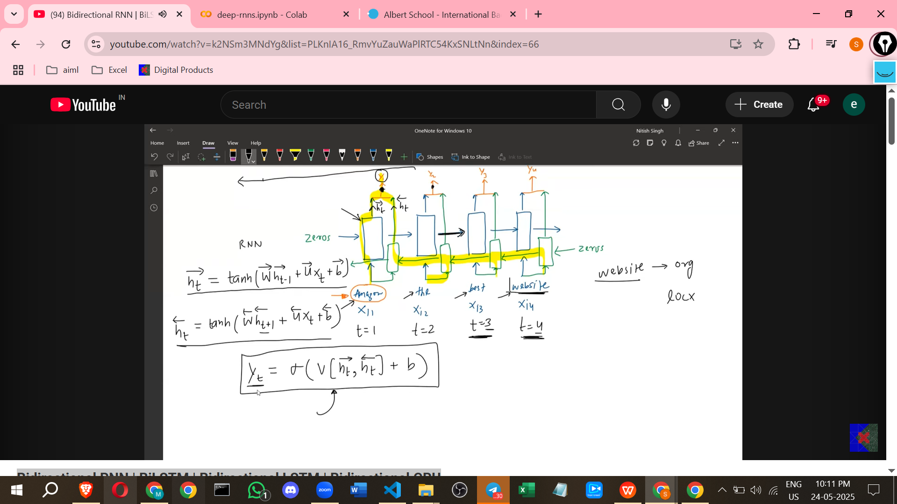
  + Each of the two RNNs (forward and backward) calculates its own hidden state at each time step.
  + For the forward RNN, the hidden state at time t (h_t_forward) depends on the input at time t (x_t) and the hidden state from the previous time step t-1 (h_{t-1}_forward).
    - Equation (as per source notation): h_t_forward = tan H(W_forward * h_{t-1}_forward + U * x_t + B_forward).
  + For the backward RNN, the hidden state at time t (h_t_backward) depends on the input at time t (x_t) and the hidden state from the *next* time step t+1 (h_{t+1}_backward). This dependence on t+1 is characteristic of the backward pass.
    - Equation (as per source notation): h_t_backward = tan H(W_backward * h_{t+1}_backward + U * x_t + B_backward).
  + The final output at time t (y_t) is calculated by combining the forward and backward hidden states for that time step. This is often done by concatenating them and then passing through an output layer (e.g., with a Sigmoid activation for classification).
    - Equation (as per source notation): y_t = sigmoid(V * concatenate(h_t_forward, h_t_backward) + Bias).
* **Implementation (Keras)**:  
  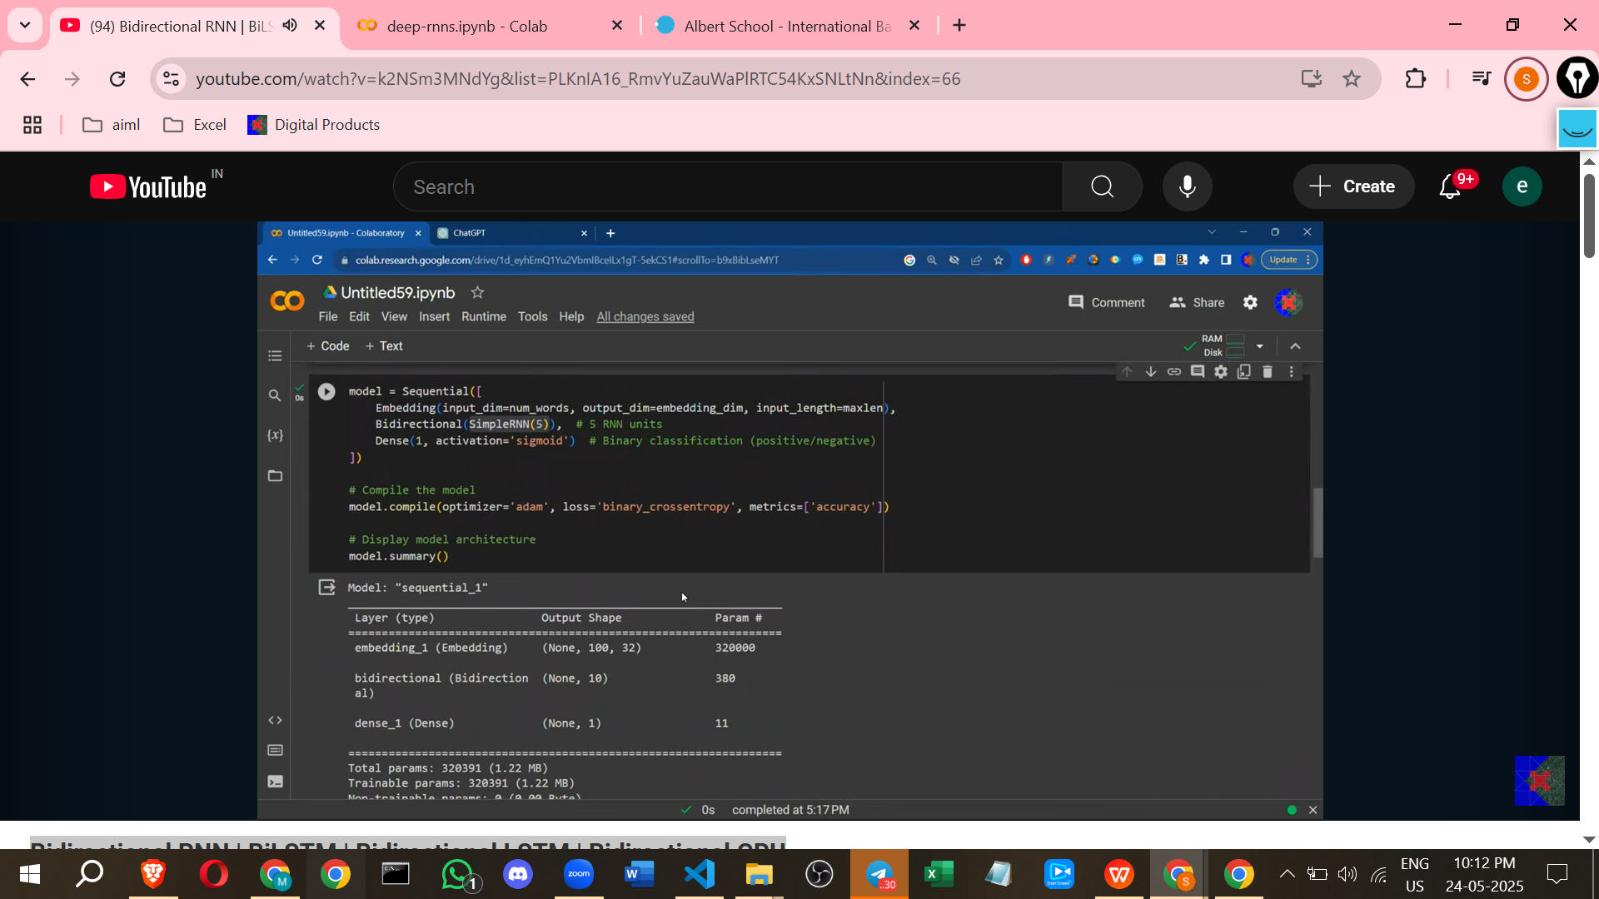

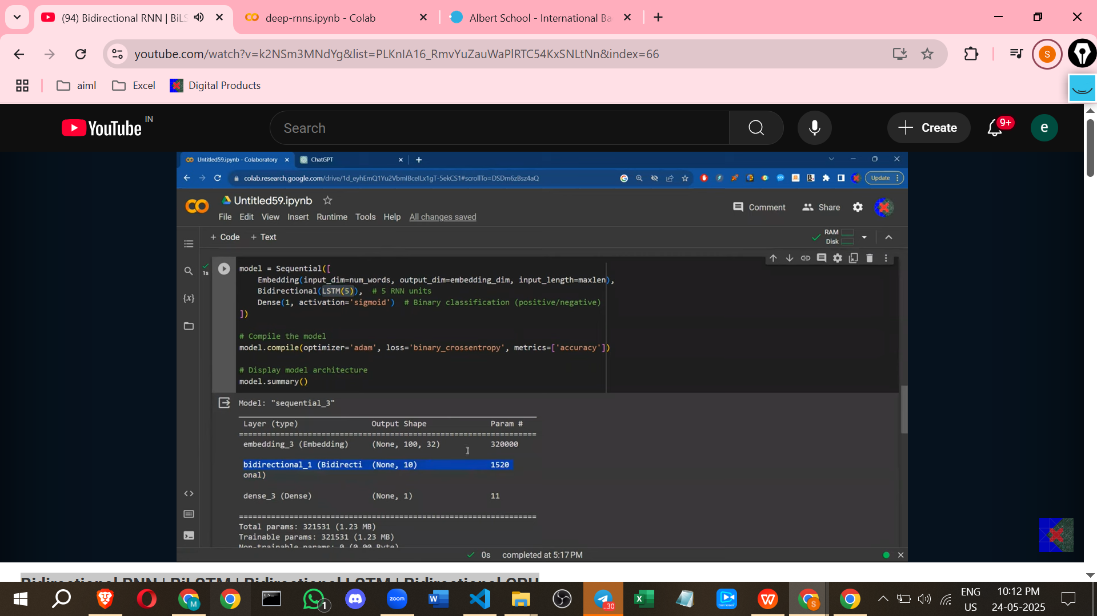

* + Keras provides a Bidirectional wrapper to easily create Bidirectional RNNs.
  + You wrap a standard RNN layer (like SimpleRNN, LSTM, or GRU) inside the Bidirectional wrapper.
  + Example code structure: model.add(Bidirectional(SimpleRNN(units=5))).
  + **Parameter Count**: Using the Bidirectional wrapper **doubles** the number of trainable parameters (weights and biases) compared to the wrapped layer alone. This is because there are now two separate sets of weights and biases, one for the forward pass and one for the backward pass.
    - *Additional Point (Not in source)*: The forward and backward layers learn independent representations and weights, allowing them to capture different aspects of the data flow.
* **Applicability to LSTM and GRU**:  
  + The concept of Bidirectional processing is **applicable to any type of RNN cell**.
  + You can create **BiLSTM** (Bidirectional LSTM) by wrapping an LSTM layer in the Bidirectional wrapper.
  + You can create **BiGRU** (Bidirectional GRU) by wrapping a GRU layer.
  + BiLSTM is commonly used, perhaps more so than simple Bidirectional RNNs.
  + *Additional Point (Not in source)*: BiLSTMs combine the ability of LSTMs to handle long-range dependencies with the advantage of having access to both past and future context, making them very powerful for sequence tasks like NER or machine translation.
* **Application Areas**:  
  + Bidirectional RNNs generally give good results in tasks where future context is important.
  + **Named Entity Recognition (NER)**: As seen in the example, understanding a word often requires context from after the word.
  + **Parts of Speech (POS) Tagging**: Determining the grammatical role of a word may depend on surrounding words.
  + **Machine Translation**: Translating a sentence accurately often requires looking at the entire sentence, not just translating word by word.
  + **Sentiment Analysis**: Sometimes, the overall sentiment of a sentence is only revealed at the very end.
  + **Time Series Forecasting**: Looking at data both forwards and backwards can sometimes improve forecasting accuracy. Examples: Stock price prediction, weather forecasting. BiLSTMs or BiGRUs are recommended for forecasting problems.

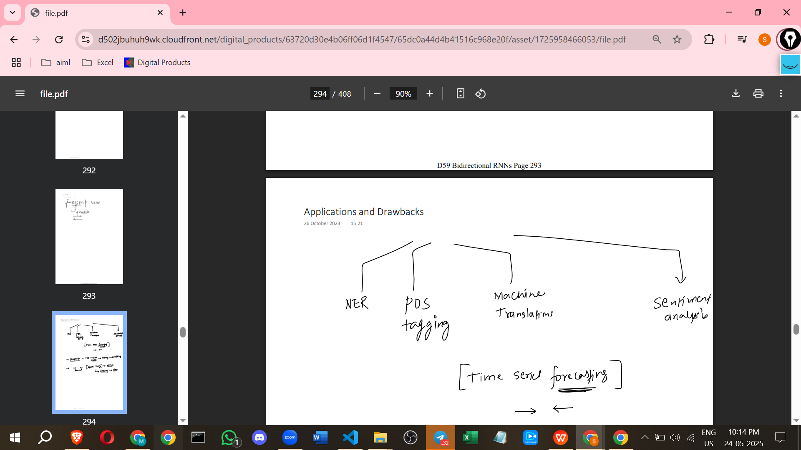

* **Drawbacks**:  
  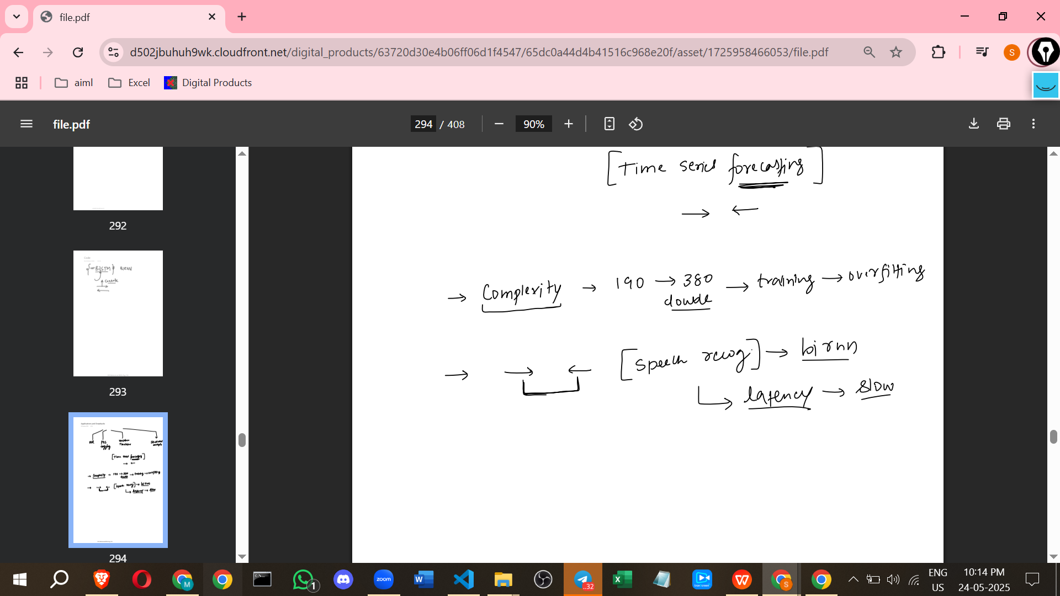
  + **Increased Complexity and Overfitting**: Doubling the parameters means the model is more complex and takes longer to train. It also increases the chance of overfitting, requiring techniques like dropout.
  + **Not Suitable for Real-time Processing (Latency Issues)**: Bidirectional models require the **entire input sequence** to be available before processing can be completed for any part of the sequence.
    - In real-time applications like speech recognition, where input arrives sequentially, a Bidirectional model must wait until the person finishes speaking the whole sentence before it can process it and provide an output.
    - This waiting period causes latency (delay in response). Unidirectional models can start processing as soon as input arrives, offering lower latency.
* **Conclusion**:  
  + Bidirectional RNNs are a valuable idea for tasks needing both past and future context.
  + They are easily implemented in frameworks like Keras using a wrapper.
  + They can be applied to various RNN types, especially LSTM and GRU.
  + It's recommended to try both unidirectional and bidirectional models on a problem to observe the difference in performance.